**Problem 3a)**

In the figure below, it is shown that on October 24, 2024 the New Horizons spacecraft is 60.18 AU away from the sun, and moving with a velocity of 13.66 km/s with respect to the sun. Assuming this velocity to be constant, it can be calculated that the New Horizons spacecraft traveled 10622016 km or 0.071 AU since October 15, 2024. Therefore, **on October 15, 2024 the New Horizons spacecraft was 60.11 AU from the Sun**.

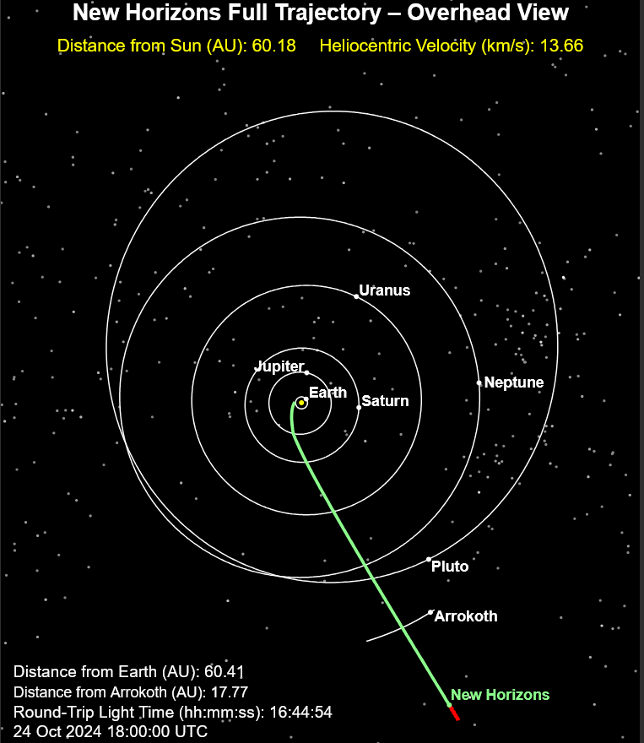

References: JHU APL Current Position – New Horizons Beyond Pluto

<https://pluto.jhuapl.edu/Mission/Where-is-New-Horizons.php>

**Problem 3b)**

|  |  |
| --- | --- |
| **Calendar Date** | **Julian Days** |
| 2006-01-19 12:00 | 2453755 |
| 2007-02-28 12:00 | 2454160 |
| 2011-03-18 12:00 | 2455639 |
| 2015-07-14 12:00 | 2457218 |
| 2019-01-01 12:00 | 2458485 |
| 2021-04-17 12:00 | 2459322 |
| 2024-10-15 12:00 | 2460599 |

Figure 1: New Horizons Timeline in Julian days